ASSIGNMENT 6

/Ass6/1.WAP using nested loops to produce the following designs:
a) *
* *
* * *
* * * *
* * * * *

#include<iostream.h>
#include<conio.h>
main()
{
clrscr();
int n;
cout<<"\n\n\n\n\nEnter the number of rows ";
cin>>n;
for (int r=1;r<=n;r++)
{
for(int c=1;c<=r;c++)
cout<<"*";
cout<<"\n\n";

}
getch();
}

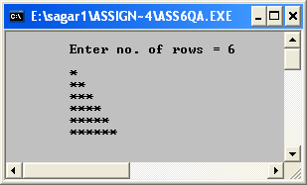

b) 1
2 3
4 5 6
7 8 9 10
11 12 13 14 15

#include<iostream.h>
#include<conio.h>
main()
{
clrscr();
int n;
cout<<"\n\n\n\n\nEnter the number of rows ";
cin>>n;
for (int r=1,flag=0;r<=n;r++)
{
for(int c=1;c<=r;c++)
cout<<++flag;
cout<<"\n\n";

}
getch();
}

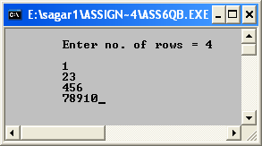

c) 1
2 2
3 3 3
4 4 4 4
5 5 5 5 5

#include<iostream.h>
#include<conio.h>
main()
{
clrscr();
int n;
cout<<"\n\n\n\n\nEnter the number of rows ";
cin>>n;
for (int r=1;r<=n;r++)
{
for(int c=1;c<=r;c++)
cout<<r;
cout<<"\n\n";

}
getch();
}

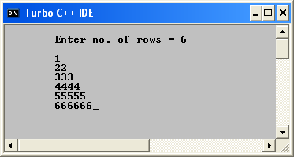

d) A
A B
A B C
A B C D
A B C D E

#include<iostream.h>
#include<conio.h>
main()
{
clrscr();
int n;
cout<<"\n\n\n\n\nEnter the number of rows ";
cin>>n;
for (int r=1;r<=n;r++)
{

for(int sp=n-1;sp>=r;sp--)
cout<<" ";
cout<<"\n";
for(int a=n-1;a>=r;a--)
cout<<" ";

for(int b=1;b<=r;b++)
cout<<"* ";
}
getch();
}

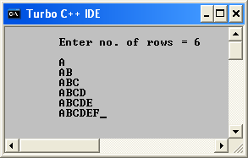
e) *
* *
* * *
* * * *

#include<iostream.h>
#include<conio.h>
main()
{
clrscr();
int n;
cout<<"\n\n\tEnter n : ";
cin>>n;
for(int r=1;r<=n;r++)
{
for(int a=n-1;a>=r;a--)
cout<<" ";
for(int c=1;c<=r;c++)
cout<<"* ";
cout<<"\n";
}

getch();
}

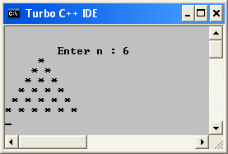

f) $ $ $ $ $
$ $ $ $
$ $ $
$ $
$

#include<iostream.h>
#include<conio.h>
main()
{
clrscr();
int n;
cout<<"\n\t Enter no.of rows = ";
cin>>n;
for(int r=1;r<=n;r++)
{
for(int c=5;c>=r;c--)
cout<<"$";

cout<<"\n";
}
getch();
}

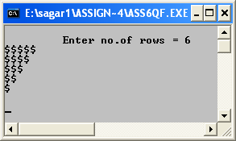

g) & & & & &
& & & &
& & &
& &
&

#include<iostream.h>
#include<conio.h>
main()
{
clrscr();
int n;
cout<<"\n\tEnter the no. of rows ";
cin>>n;
for(int r=1;r<=n;r++)
{
for(int sp=1;sp<r;sp++)
cout<<' ';
for(int c=n;c>=r;c--)
cout<<"& ";
cout<<"\n";
}
getch();
}

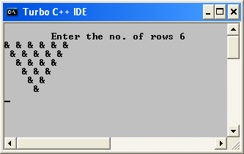

h) *
* *
* * *
* * * *
* * * * *

#include<iostream.h>
#include<conio.h>
main()
{
clrscr();
int n;
cout<<"\n Enter no.of rows ";
cin>>n;
for(int r=1;r<=n;r++)
{
for(int sp=n-1;sp>=r;sp--)
cout<<' ';
for(int c=1;c<=r;c++)
cout<<'*';
cout<<endl;
}
getch();
}

